Seminar: Vibrations and Structure-Borne Sound in Civil Engineering – Theory and Applications

Tuned Mass Dampers

Felix Stroscher
March 31st, 2006

Contents

1  2  3  4  5 | Introduction  System without TMD – 1 DOF System  System with TMD – 2 DOF System  Optimisation of the TMD  Examples | 3  4  5  7  8

1 Introduction

A tuned mass damper is generally spoken, a mass that is connected to a structure by a spring
and a damping element without any other support, in order to reduce vibration of the structure.

Tuned mass dampers are mainly used in the following applications:

- tall and slender free-standing structures (bridges, pylons of bridges, chimneys, TV towers) which tend to be excited dangerously in one of their mode shapes by wind,

- stairs, spectator stands, pedestrian bridges excited by marching or jumping people. These vibrations are often not dangerous for the structure itself, but may become very unpleasant for the people,

- steel structures like factory floors excited in one of their natural frequencies by machines, such as screens, centrifuges, fans etc.,

- ships exited in one of their natural frequencies by the main engines or even by ship motion.

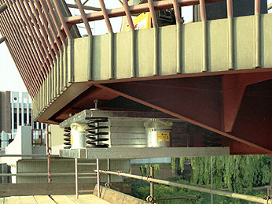

Application of a Tuned Mass Damper at a balcony
2 System without TMD – 1 DOF System

Thin structures with low damping have a high peak in their amplification if the frequency of excitation is similar to their eigenfrequency. The result will be high dynamic forces and deformations that could decrease the comfort for human beings or even be dangerous to the structure.

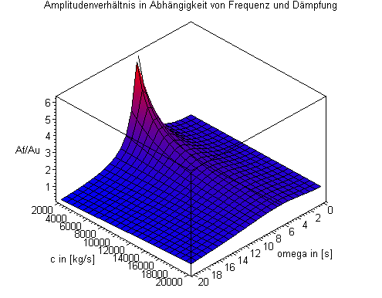
Amplification function of a SDOF System with respect to the frequency of excitation omega and the damping constant c

To get rid of these vibrations engineers have several opportunities:

- Strengthen the structure to get a higher eigenfrequency

- Application of dampers

- Application of tuned mass dampers

The first possibility is in generally not applicable due to the low effect of higher stiffness on the eigenfrequency. The Apllication of normal dampers connected to the ground is often highly effective but in many cases not applicable because the dampers must have a connection to the ground.
3 System with TMD – 2 DOF System

The resulting differential equations for the displacements u1 and u2 are

$\begin{aligned}m_{1}⋅{\overset{¨}{u}}_{1}+k_{1}⋅u_{1}+k_{2}⋅\left(u_{1}−u_{2}\right)+c_{2}⋅\left({\overset{˙}{u}}_{1}−{\overset{˙}{u}}_{2}\right)=p_{0}⋅\text{cos}\left(ω⋅t\right) \\ \\ m_{2}⋅{\overset{¨}{u}}_{2}+k_{2}⋅\left(u_{2}−u_{1}\right)+c_{2}⋅\left({\overset{˙}{u}}_{2}−{\overset{˙}{u}}_{1}\right)=0\end{aligned}$

$\frac{u_{1\text{,max}}}{u_{1,\text{stat}}}=\sqrt{\frac{4⋅ξ^{2}⋅β^{2}+{\left(β^{2}−α^{2}\right)}^{2}}{4⋅ξ^{2}⋅β^{2}{\left(β^{2}−1+μ⋅β^{2}\right)}^{2}{\left[μ⋅α^{2}⋅β^{2}−\left(β^{2}−1\right)⋅\left(β^{2}−α^{2}\right)\right]}^{2}}}$After solving the equations we get the amplification function

$μ=\frac{m_{2}}{m_{1}}$$ξ=\frac{c_{2}}{2⋅m_{2}⋅ω_{2}}$$u_{1,\text{stat}}=\frac{p_{0}}{k_{1}}$$ω_{2}=\sqrt{\frac{k_{2}}{m_{2}}}$$α=\frac{ω_{2}}{ω_{1}}$$β=\frac{ω}{ω_{1}}$

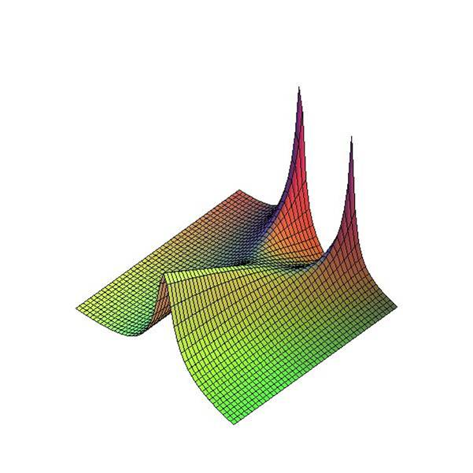
By consideration of the Amplification function we observe two peaks if the damping mass is not damped. If the damping between main mass and damping mass is infinite high the system behaves like a SDOF System.

Intersections of the amplification function
4 Optimisation of the TMD

To optimise the damping and the spring constant for the maximum effect of the Tuned Mass Damper the lowest peaks in the amplification function must be found. This will be where the points S and T have the same value.

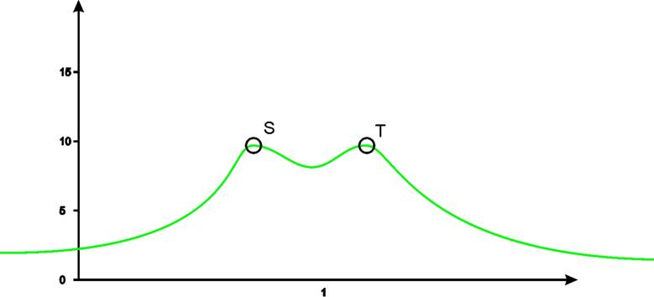
Optimal intersection of the amplification function

$α=\frac{1}{1+μ}$We get the optimal ratio of the eigenfrequencies that will deliver the optimal spring constant

The optimal damping ratio is

$ξ_{\text{opt}}=\sqrt{\frac{3⋅μ}{8⋅{\left(1+μ\right)}^{3}}}$

For practical use of the TMD the following values are used:

Ratio of masses:

The higher the mass of the TMD is, the better is the damping.
Useful: from 0.02 (low effect) up to 0.1 (often constructive limit)

Damping Ratio of Lehr: ξ

0.08 - 0.20

Ratio of frequencies: α

0.98 - 0.86

5 Examples

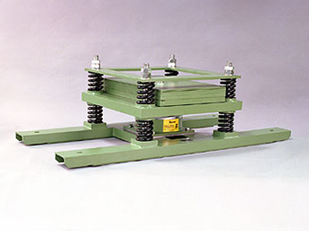
Regular tuned mass damper

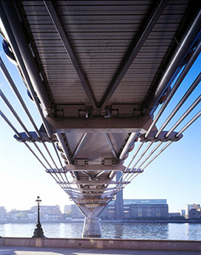
TMDs at the Millenium Bridge London

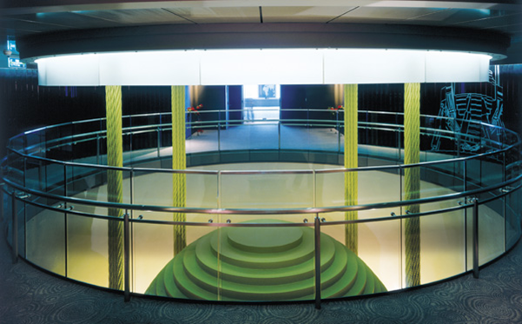

Pendular damper in the Taipeh 101 Tower

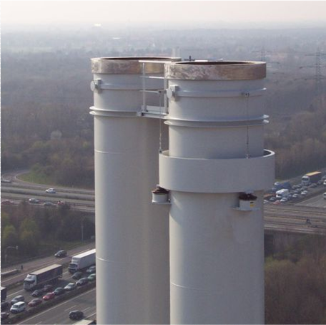
Tuned Mass Damper Ring around a steel chimney

