Seminar: Vibrations and Structure-Borne Sound in Civil Engineering – Theory and Applications

Mathematical aspects of mechanical systems eigentones

Andrey Kuzmin

April 1st, 2006

Abstract

Computational methods of mechanical systems eigentones in linear and nonlinear statements are considered. Unlike the FEM, all chosen area of a construction is approximated. The main steps of the Forces Method for rod systems are described. Stages of computation and approximation on Bubnov-Galerkin’s Method for plates and shells are more in detail described. Some examples are shown.

Contents

1 Introduction 3
2 Eigentones (free vibrations) of rod systems 3
3 Eigentones of plates and shells 4
3.1 Properties of eigentones 4
3.2 A rectangular plate, fixed at edges. A linear problem 5
3.3 A nonlinear problem. Bubnov-Galerkin’s method 6
The first stage. 7
The second stage. 8
3.4 The bicurved shell 9
4 Conclusion 11

1 Introduction
The theory of mechanical vibrations has numerous applications in various areas of technique. Vibrations of mechanical systems irrespective of their form and purpose obey to the same physical laws. Investigation of these vibrations makes the general theory of vibrations.
The linear vibration theory is the most fully developed. The theory was developed for systems with several degrees of freedom in XVIII century in the “Analytical mechanics” by Lagrange. In the works of some authors of XIX century, especially Rayleigh, the foundation of the linear vibration theory of systems with the infinite number degrees of freedom was given. The linear theory was completed in XX century. Nowadays the problems of vibration in the linear processes are related only with a choice of degrees of freedom and definition of external influences, that is with a selection of the calculated scheme.
Many vibrations problems of mechanical systems suppose both linear and nonlinear statement. For example, problems on activity of a displacement load which arose more than a hundred years ago at designing of great railway bridges; afterwards other areas of application of the same theory were also defined (for example, vibrations of pipelines).
Many physical phenomena observable at vibrations of mechanical systems, are impossible to explain, on the base of the linear theory only. Therefore the nonlinear vibration theory is necessary mainly not to find small quantitative corrections to the results obtained from the linear theory. The role of the nonlinear theory is much more important. With its help phenomena which escape from a field of vision at any attempt to linearize a considered problem should be described.
Unfortunately, the nonlinear equations, as a rule, do not suppose the solution in the closed form. Therefore efforts of the founders of the nonlinear theory, since Poincare and Lyapunov, were directed on creation of rational algorithms which allow obtaining the approximate results with a necessary level of precision. Some of methods of the nonlinear theory allow making successive approximations (for example methods of Poincare and Lyapunov, Krylov-Bogolyubov's method). Other methods (for example Bubnov-Galerkin’s method) allow transforming a solution of nonlinear differential partial equations to systems of the ordinary differential equations which then are solve by means of a Runge-Kutta method.

2 Eigentones (free vibrations) of rod systems
Let's consider rod systems in which the distributed mass is concentrated in separate sections (that is systems with a finite number of degrees of freedom). They are calculated by a forces method in the matrix form.
To define frequencies of free vibrations in the given system, it is necessary to define displacements from a unit forces applied in directions of masses vibrations. Then to construct a stiffness matrix of system
,
where
f – the stiffness matrix of separate elements;
b – the gain matrix depend on the unit forces applied in a direction of masses vibrations in the given system;
b₀ – matrix equal to the matrix b, constructed for statically definable system. That is if the given system is statically determinate, then b₀ = b.
“*” – the transposition operator

Further construct a diagonal masses matrix M, calculate matrix product D = BM and consider system of homogeneous equations
or , (1)
where ;
ω – frequency of free vibrations  of the given system;
Е – a unit matrix;
X – an amplitudes vector of displacements.

As at oscillations X it is not equal to zero (), the determinant
.
Then we compute the determinant, eigenvalues and corresponding eigenvectors of matrix D.

3 Eigentones of plates and shells

3.1 Properties of eigentones
If character of eigentones of a construction is known, it is possible to speak about its internal properties which arise at activity of exterior impacts.
As is known, a plate and a shell represent systems with infinite number of degrees of freedom. It means that the number of eigenfrequencies is infinite, and a certain form of vibrations corresponds to each frequency.
Displacements amplitudes of various points of system do not depend on frequency and are determined by initial conditions. These requirements include:
- deviations of elements of a plate or a shell from equilibrium position
- velocities of these elements in an initial instant.
It follows that parameters of system stiffness are considered constant. But, as is known from the theory of plates and shells, characteristics of stiffness are considered as stationary values at small deflections. Hence interior forces are reduced to stress of a bending down.
If deflections are comparable to thickness of a plate, then arise nonlinear vibrations. Thus on common classification introduced by Bubnov, we pass from the rigid plates to flexible. Parameters of stiffness for flexible plates are various and depend on a deflection. It also concerns absolutely flexible plates (membranes); stresses of bending are neglect in them down in comparison with stresses in a median surface.
For shells tension includes, generally speaking, gains of a bending down and gains in a median surface at small deflections. However deformations at greater deflections are characterized by a modification in the ratio between these gains again.
But as frequency of eigentones is related with parameters of system stiffness for flexible plates or shells frequency depends on how much the system deviates from equilibrium position or, in other words, depends on vibration amplitude. This circumstance is the most typical for the thin-wall constructions receiving big displacements.
In case of a plate dependence between the typical deflection A and frequency of the linear system ν has the form shown on fig. 1, a. Frequency will increase at increase of amplitude. The system with such performance refers to thin. For a shell similar dependence can be different, see fig. 1, b. The initial segment here declines to an ordinate axis, and the corresponding characteristic refers to soft.

1
A
ν
1
A
ν
a) Thin system
b) Soft system

Fig. 1. Possible of dependence between the characteristic deflection
and nonlinear eigentones frequency.

Line refers to a skeletal line. She reflects the main properties of deformable system. Various diagrams of forced vibration of system are grouped around this line.
Solution of nonlinear dynamic problems in which time and spatial coordinates are independent variables, is difficult. Therefore one often limits himself, as a rule, with researching the lowest tones of vibrations and, first of all, a main tone. When considering such problems a plate or a shell is lead to system with one degree of freedom, approximating their curved surface (monomial approximation).

3.2 A rectangular plate, fixed at edges. A linear problem
We start from of a rectangular plate, fixed at edges. Consider the problem in the linear statement.
Let a, b be the sides of a plate, and h – the thickness of a plate. We direct coordinate axises x, y along sides of a main contour.
Let's take advantage of the linear equation for a plate:
, (2)
where – cylindrical stiffness;
E – Young’s modulus;
μ – the Poisson's ratio;
w – function of a deflection;
γ – density of the plate material;
g – the free fall acceleration;
– the differential functional.

On Kantorovich's method we approximate the deflection with following expression
,
where f(t) – some temporal function.
Substituting the equation (2) instead of function f(t) and integrating we obtain the differential equation concerning time t:
,
here . The square of eigentones frequency at small deflections has form
,
where , с – the velocity of spreading of longitudinal elastic waves in a material of a plate:
.
In fig. 2 character of a rectangular plate wave formation at vibrations of first three forms is shown:
Case a) – the plate executes vibrations on the lowest frequency with formation of one half-wave in a direction of each side.
Case b) – two half-waves in one direction and one half-wave in another direction correspond to higher frequency.
Case c) – two half-waves in each direction correspond to the third frequency.

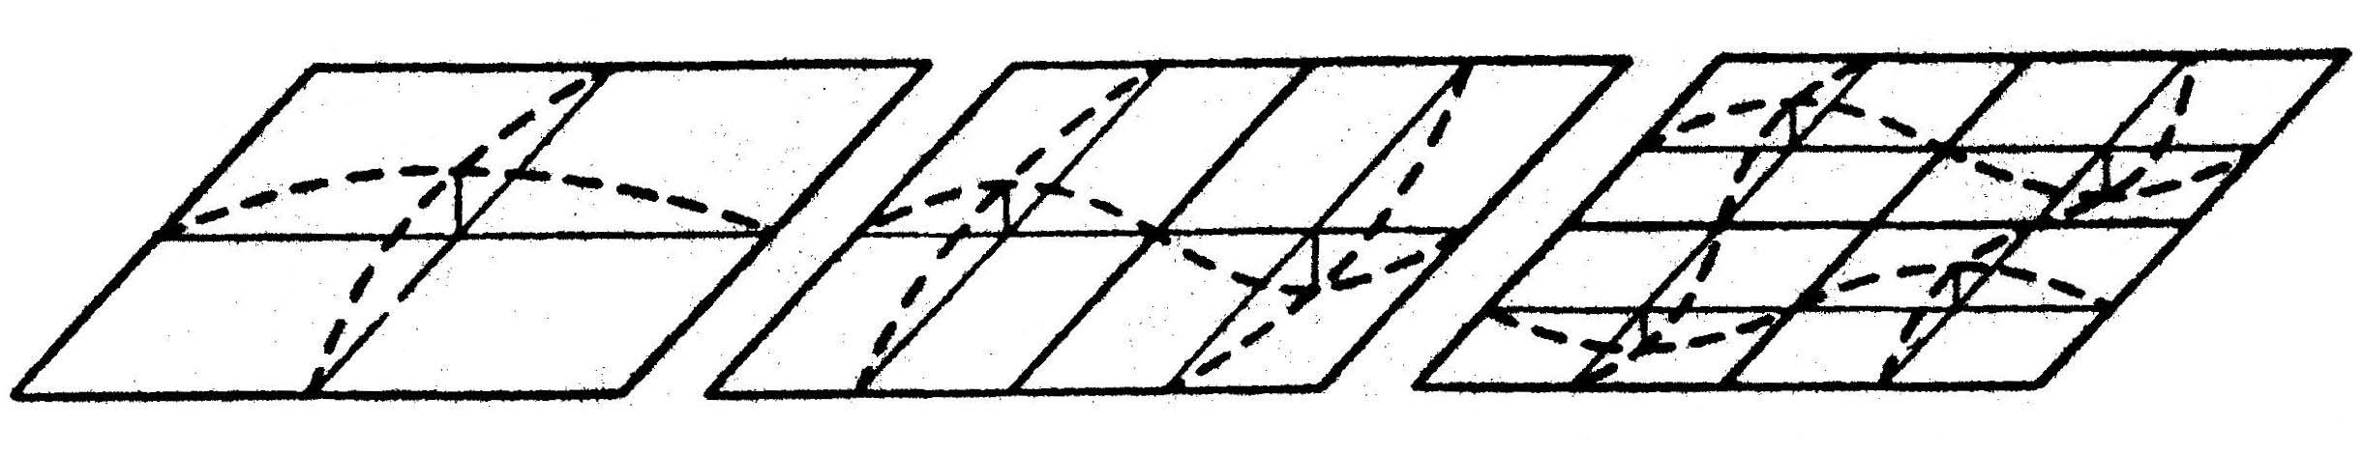
m = n = 1
m = 2, n = 1
m = n = 2

Fig. 2. Character of wave formation of a rectangular plate at vibrations;
a) of the first form, b) of the second, c) of the third one.

3.3 A nonlinear problem. Bubnov-Galerkin’s method
Now we consider nonlinear vibrations of a rectangular plate, fixed at edges and considered above. Our purpose is to examine vibrations of a plate at amplitudes which are comparable with its thickness. As to boundary conditions for displacements and stresses in a median surface we shall assume, that edges of a plate are related with elastic ribs.
Assume that the ratio of the sides of a plate is within the limits of . We spread a section area of elastic ribs bordering a plate, along the corresponding side. Suppose coordinate axises x, y are directed along the sides а, b. We take advantage of the main equations of the shells theory at the main curvatures are equal to zero (k_{x} = k_{y} = 0):
– the equilibrium equation; (3)
– the deformation equation, (4)
where Φ – a stress function;
differential functional .

Let's set expression of a deflection
. (5)
Substituting (5) in the right member of the equation (4), we shall obtain the equation, which private solution is:
.
Here
.
Let’s define , , where F_{x} and F_{y} – section areas of ribs in a direction of axes x and y.
Then the solution of a homogeneous equation will have the form:
.
where , – the stresses applied to the plate through boundary ribs; they are considered as positive at a tensioning:
Finally
.
We have written out main relations for a problem about eigentones of a rectangular plate. These relations lead to a differential partial equation concerning function of a deflection (). The exact solution of the equation misses. But there are some methods which allow leading an appoximative integration of the equation at various boundary conditions. Let’s get acquainted with Bubnov-Galerkin’s method. We shall solve in two stages.

The first stage.
Let’s apply Bubnov-Galerkin’s method to the equation (3) for some fixed instant t. Suppose X has the form
.
Generally we approximate functions w(x,y,t) in the form of series
where f_{i} – the parameters depending on t;
η_{i} – some given and independent functions, which satisfy to boundary conditions of a problem.

On Bubnov-Galerkin’s method we write out n equations of type
. (6)
In our solution η₁ has the form
.
Hence, integrating (6) and passing to dimensionless parameters, we obtain the equation
, (7)
where the dimensionless parameters ,
.
(8)
Parameter is called the square of the main frequency of a plate eigentones:
.
Thus, having an initial nonlinear differential partial equation of the fourth degree (3) we have as a result the nonlinear differential equation in ordinary derivatives, and, besides, of the second degree.
Research of the equation (7) represents the elementary problem of the common nonlinear vibrations theory of mechanical systems.

The second stage.
Now we integrate of the equation (7) containing only one independent variable – time. Consider the simply supported plate.
We obtain the solution, satisfying to this variant, at . But if to assume, that value of a deflection is unequal to zero, then ν_{x} and ν_{y} tend to infinity (that is ribs are absent). From (8) hence
.
Let's present the temporal function in the form
, (9)
where А – dimensionless amplitude,
ω – vibration frequency.

Denote by Z the left-handed part of the equation (7):
.
Further integrate Z over period of vibrations :
,
from which we obtain the equation expressing dependence between frequency of nonlinear vibrations ω and amplitude A:
.
We define ν as the ratio of a variable ω to corresponding frequency of the linear vibrations ω₀; . Then
.
Thus we can construct a skeletal line of the thin type in coordinate’s ν, A (fig. 3). At rather small amplitudes we have ν → 1 (ν tends to one). Vibration frequency increases with increasing the amplitude, both besides more and more sharply.

A
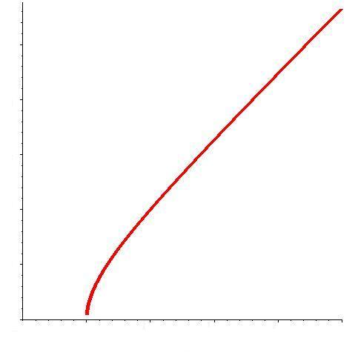
0
2
4

υ
1
3
3
1
2
4

Fig. 3. A skeletal line of the thin type for ideal rectangular
plate at nonlinear vibrations of the general form.

3.4 The bicurved shell
Now we consider shallow and rectangular in a plane of the shell (fig. 4).

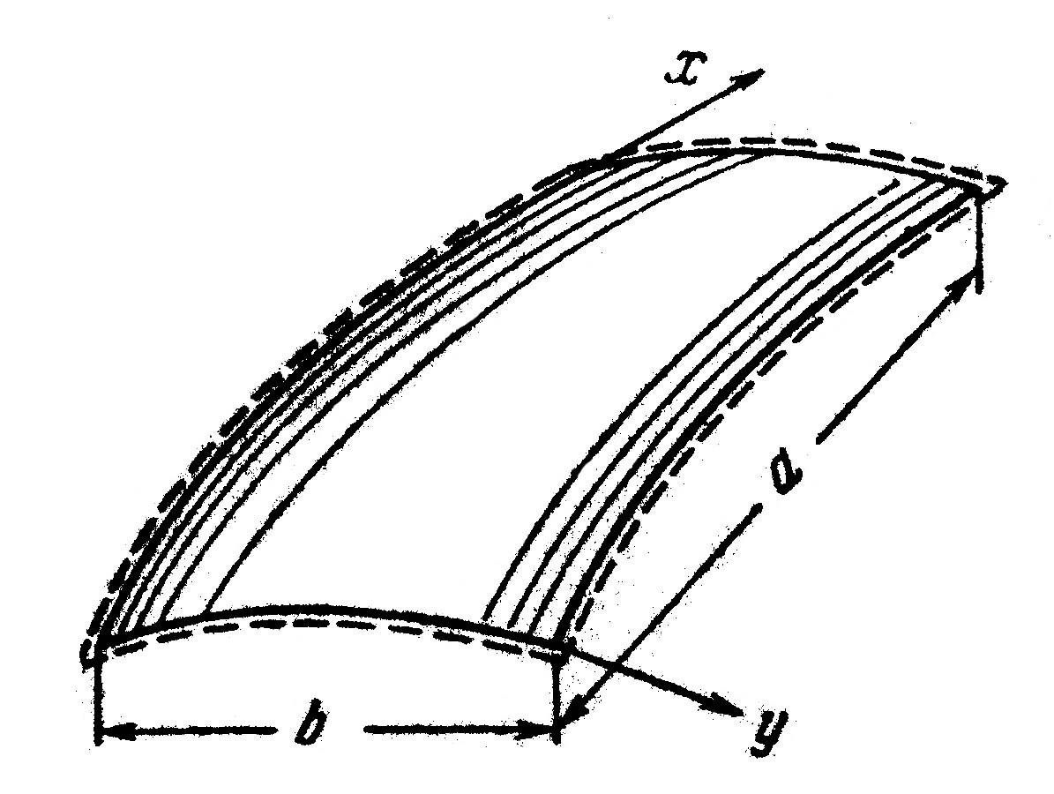
Fig. 4. The shallow bicurved shell.

Suppose the shell fixed at edges. And suppose it has initial deviations in the median surface.
Main contour sides sizes in a plane of are equal a, b. The main shell curvatures k_{x}, k_{y} are assumed by constants:
The dynamic equations of the nonlinear theory of shallow shells have the form:
;
,
where the differential functional
.
For full and initial deflections are define by
.
Using the method considered above, we obtain the following ordinary differential equation of shell vibrations:
, (10)
here ; – the square of the main frequency of ideal shell eigentones at small deflections:
,
where
,
с – the velocity of spreading of longitudinal elastic waves in a material of a plate. Dimensionless parameters of shell curvature have the form
.
Variables α, β, η have the form ; ; .
Thus we obtain the following equation for definition of an amplitude-frequency characteristic
,
where
.
In fig. 5 data of the evaluations concerning the shell at are shown. Also for comparison data for a plate () and for a cylindrical shell () are shown.

A
ν
2
4
6
8
0
1
2
Fig. 5. The amplitude-frequency dependences
for shallow shells of various curvature.

4 Conclusion
We have considered linear and nonlinear eigentones of rods, plates and shells which assumed the construction to have one degree of freedom (monomial approximation of a deflection). If to set the infinite number of degrees of freedom then the process of examining of free vibrations becomes difficult. Thus a skeletal line (see fig. 5) will differ for different points of a shell because different points will not only have different frequencies of vibrations but can oscillate in an antiphase. The skeletal line will reflect local and general loss of stability.
First of all, the free vibrations of constructions are necessary to research in order not to allow occurrence of a resonance. Besides as researches of thin-wall constructions have shown, at occurrence of nonharmonic vibrations there is a danger of damages related with antiphase of separate points of a shell.
Thus, at designing constructions (for example, pipelines, railway bridges or thin-wall shells of buildings) it is necessary to consider vibrating characteristics of these constructions apart from strength and sustainability.

References
- Ilyin V.P., Karpov V.V., Maslennikov A.M. Numerical methods of a problems solution of building mechanics. – Moscow: ASV; St. Petersburg.: SPSUACE, 2005.
- Karpov V.V., Ignatyev O.V., Salnikov A.Y. Nonlinear mathematical models of shells deformation of variable thickness and algorithms of their research. – Moscow: ASV; St. Petersburg.: SPSUACE, 2002.
- Panovko J.G., Gubanova I.I. Stability and vibrations of elastic systems. – Moscow: Nauka. 1987.
- Volmir A.S. Nonlinear dynamics of plates and shells. – Moscow: Nauka. 1972.

